**Pooling Layer**

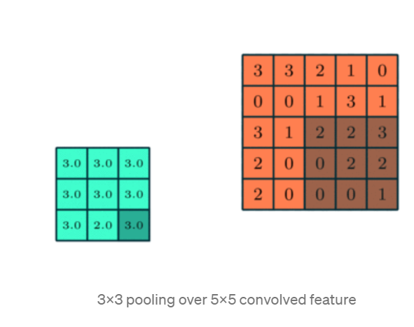

Similar to the Convolutional Layer, the Pooling layer is responsible for reducing the spatial size of the Convolved Feature. This is to decrease the computational power required to process the data through dimensionality reduction. Furthermore, it is useful for extracting dominant features which are rotational and positional invariant, thus maintaining the process of effectively training the model.

There are two types of Pooling: Max Pooling and Average Pooling. Max Pooling returns the maximum value from the portion of the image covered by the Kernel. On the other hand, Average Pooling returns the average of all the values from the portion of the image covered by the Kernel.

Max Pooling also performs as a Noise Suppressant. It discards the noisy activations altogether and also performs de-noising along with dimensionality reduction. On the other hand, Average Pooling simply performs dimensionality reduction as a noise-suppressing mechanism. Hence, we can say that Max Pooling performs a lot better than Average Pooling. 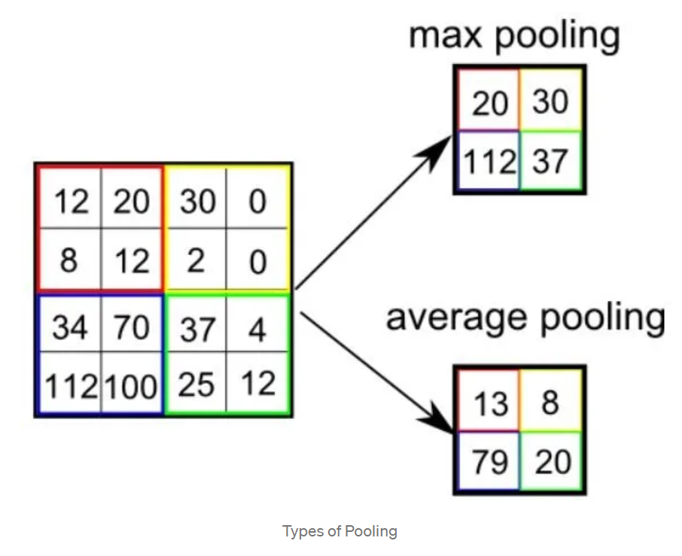 The Convolutional Layer and the Pooling Layer, together form the i-th layer of a Convolutional Neural Network. Depending on the complexities in the images, the number of such layers may be increased for capturing low-level details even further, but at the cost of more computational power.

After going through the above process, we have successfully enabled the model to understand the features. Moving on, we are going to flatten the final output and feed it to a regular Neural Network for classification purposes.

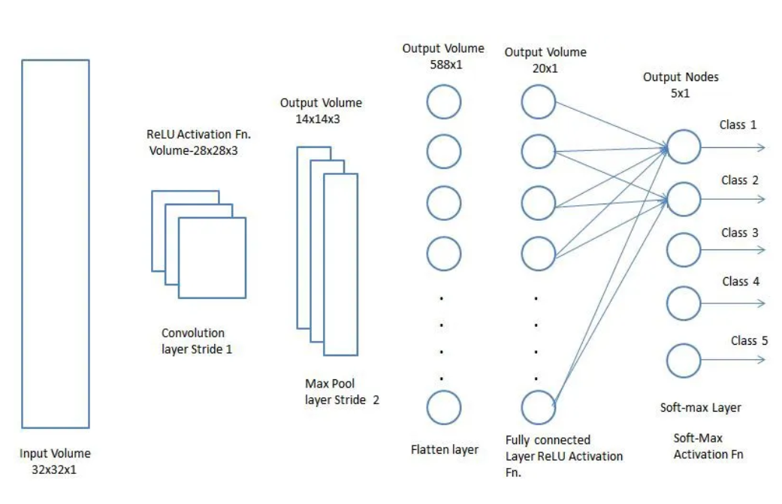

Adding a Fully-Connected layer is a (usually) cheap way of learning non-linear combinations of the high-level features as represented by the output of the convolutional layer. The Fully-Connected layer is learning a possibly non-linear function in that space.

Now that we have converted our input image into a suitable form for our Multi-Level Perceptron, we shall flatten the image into a column vector. The flattened output is fed to a feed-forward neural network and backpropagation is applied to every iteration of training. Over a series of epochs, the model is able to distinguish between dominating and certain low-level features in images and classify them using the Softmax Classification technique.

There are various architectures of CNNs available which have been key in building algorithms which power and shall power AI as a whole in the foreseeable future. Some of them have been listed below:

* LeNet
* AlexNet
* VGGNet
* GoogLeNet
* ResNet
* ZFNet